K.K. Collage of Engineering &

Management Dhanbad

Project Report
On

E Voting Management System
Submitted By
Chandramani Kamari
(Reg. No.:22032445013)
Sanjana Sahu
(Reg. No.:22032455028)


Under the Guidance of
Mr. Rajnish Kumar
Head of department
(2022-2026)

K.K. Collage of Engineering & Management
Dhanbad

CERTIFICATE

This is to certify that this report of “E Voting System Management”
embodies the original work done by Chandramani Kumari (Reg.
No.:22032445013),Sanjana Sahu (Reg. No.: 22032445028), who
carried out the project under my supervision.

Internal Examiner External Examiner
Mr. Rajnish Kumar

Department of Computer Science

ACKNOWLEDGEMENT

The satisfaction that accompanies after the successful completion of any task would be incomplete without mentioning of people whose ceaseless cooperation made it possible, whose constant guidance and encouragement crown all efforts
with success.First of all, we would like to express our gratitude to the Principal of our college,
Dr. Ramkrishna Prasad chakraborty for his guidance and inspiration in completing this project. Further, we are extremely thankful to Mr. Rajnish
Kumar and all the faculties of K.K. Collage of Engineering & Management , Dhanbad
for their coordination and cooperation and for their kind guidance and encouragement.
We also thank our colleagues who helped in successful completion of the project.
This project has indeed helped us to explore more knowledgeable avenues related
to our topic and we are sure that it will help us in our future.

TABLE OF CONTENT:

Chapter 1: Introduction Page no.
- Introduction to the project 6
- Problem definition 7
- Objective 7
• Limitations 8

Chapter 2: Hardware and software requirement
- Software requirements 9
- Hardware requirements 9

Chapter 3: System Analysis
- Purpose of system 10
- Project scope 11
- Existing system 12

Chapter 4: Implementation
- HTML 13
- CSS 14
• PHP 15

• JAVASCRIPT 15

Chapter 4: Design

Chapter 5: Coding 16

Chapter 6: Output Screen 31

Chapter 7: Advantages

Chapter 8: CONCLUSION

REFERENCES 40

ABSTRACT

We are developing an on-line voting system by taking advantage of centralized database with a web interface. The main concept of this project is to build a
website , which will be able to allow people to cast their vote through on-line.
Time saving , working load reduced , information available at time and it provides
security for data. In a democratic
country like India we are not getting 100% of voting. People are not ready to poll
their vote because of many factors like people can’t go to the polling stations to
cast their vote(especially aged persons and physically challenged people). People may be at remote places . There are several issues with traditional paper based
voting like ridging votes during election , insecure or inaccessible polling stations, inadequate polling materials and also inexperienced personnel. This On-line
Voting System seeks to address the above issues. With this system , the citizens
may get ample time during the voting period. Every citizen is registered first and
all the details are managed at centralized database. And at the time of elections
the citizens will be login through their credentials and cast their vote
CHAPTER 1: INTRODUCTION

Introduction to the Project: -

Elections allow the populace to choose their representatives and express their preferences for how they will be governed . The election system must be sufficiently robust to withstand a variety of fraudulent behaviours and must be sufficiently transparent and comprehensible that voters and can- didates can accept the results of an election. The voting system must be tamper-resistant
Online voting systems are software platforms used to securely conduct elections. As a digital platform
, they eliminate the need to cast votes using paper or having to gather in person . Presently voting is performed by using ballot paper and the counting is done manually , hence it consumes a lot of time . There can be possibility of invalid votes.
In our proposed systems , voting and counting is automated . It makes the election process easy and secure
It also protect the integrity of every vote by preventing voters from being able to vote multiple times . Voting services helps to save time , stick to best practices , and meet internal requirements and/or ex- ternal regulations , such as third-party vote administration needs .

Problem Definition:

Now-a-days people find very less time to cast the vote .And there are several issues where India, democratic country is unable to get polling of 100%.In order to make voting easy and secure , online voting system
helpful. Voter has to register first and then login .Voter is authenticated and then proceed to voting page . Voter cast the vote and logout. One can view the results at any instance of time .

Objectives:

- As everything became on-line now-a-days , making the voting process As everything became on-line now-a-days , making the voting process also on-line
- To make more convenient for the people to vote especially for people who stay at remote places like army or people who migrated to other places for their studies or occupations
- To prevent tampering of votes
- To Provide high security by using secured authentication mechanisms
- To increase Voting percentage

Limitations Of Project:
We are developing a website for casting the vote online. While casting the vote the most important thing is security. We are providing security through the OTP authentication . OTP also provides strong security but it would be more secure if we use fingerprint detection and cornea detection and map it with the aadhar database details.

CHAPTER 2

Hardware and Software Requirement

Software Requirements:
- Microsoft Windows 7/8/10
- XAMP (My SQL, Apache, PHP)
- Notepad++ or any other text editor
- Chrome or any other browser

Hardware Requirements:
- Intel Processor 20 GHz or above
- 2 GB RAM or more
- 160 GB or more Hard Disk Drive or above

CHAPTER 3
System Analysis

Purpose of system

Increased Accessibility and Convenience: E-voting allows voters to cast ballots from
a variety of locations (home, office, or specific kiosks) using the internet or dedicated machines. This is particularly beneficial for voters with disabilities, those living in
remote areas, expatriates, or deployed military personnel.
Enhanced Efficiency and Faster Results: The automation inherent in e-voting systems allows for immediate tabulation of results once polls close, significantly reducing the
time and manual labor associated with counting paper ballots.
Cost Savings: By eliminating the need for printing, transporting, and storing
large quantities of paper ballots,e- voting can lead to long-term cost efficiencies
for election organizers.
Improved Accuracy and Reduced Errors: E-voting systems can minimize
human errors in counting and prevent common issues like "overvoting" (selecting
too many candidates) or "undervoting" (selecting too few), which can spoil a paper
ballot.
Increased Voter Turnout (Potential): By removing barriers such as long lines
and inconvenient polling locations, e-voting aims to encourage higher participation rates
Among eligible voters, particularly younger demographics or those with busy schedules.
Security and Auditability: High-quality e-voting systems incorporate security
measures like encryption, secure authentication, and, in some cases, voter-verified
paper audit trails (VVPATs) or end-to-end auditable (E2E) systems to prevent fraud,
protect anonymity, and ensure the results are verifiable

Project Scope
Enhanced Accessibility: Allowing voters to cast their ballots from a remote location via web or mobile
platforms, increasing overall voter turnout.
Improved Security: Utilizing advanced technologies like encryption, digital signatures, and potentially
blockchain to ensure vote integrity and protect voter anonymity.
Increased Efficiency: Automating the voting and vote-counting processes to reduce the time, cost, and
manpower associated with manual elections.
Greater Transparency: Providing an auditable system where
stakeholders can verify the fairness and accuracy of the election results, building public trust.

Existing system
In our country , we are following the traditional paper based voting system or EVMs which has several drawbacks . Whatever the system we follow, we need to move to the polling stations to cast the vote and it leads to
gathering of people in larger number.

CHAPTER 4

Implementation

PHP:
PHP is an acronym for "PHP: Hypertext Preprocessor”.PHP is a widely-used, open source
scripting language.PHP scripts are executed on the server.PHP is free to download and use
PHP can be used for the following:
    - PHP can generate dynamic page content
    - PHP can create, open, read, write, delete, and close files on the server
    - PHP can collect form data
    - PHP can send and receive cookies
    - PHP can add, delete, modify data in your database
    - PHP can be used to control user-access
    - PHP can encrypt data

HTML:
HTML (Hypertext Markup Language) is the set of markup symbols or codes inserted in a file intended for display on a World Wide Web browser page. The markup tells the Web browser how to display a Web page's words and images for the user. Each individual markup code is referred to as an element (but many people also refer to it as a tag). Some elements come in pairs that indicate when some display effect is to begin and when it is to end.

CASCADING STYLE SHEET (CSS):

CSS stands for Cascading Style Sheets.CSS describes how HTML elements are to be displayed on screen, paper, or in other media.CSS saves a lot of work. It can control the layout of multiple web pages all at once.External stylesheets are stored in CSS files
JAVASCRIPT:

  - Client side validation of form elements instead of sending data to server every time.
  - To insert new elements such as text box etc. to the website on the go.
  - To provide users notifications from the server.
  - To load data in the background from the server and loaded on to the page side without reloading.

DESIGN

Introduction:
The design phase shows how the project has been implemented.The components involved in the project.In this one or more designs are developed which gives the apparent results for the project.
UML(Unified Modelling language) is a standard language for specifying, visualising, constructing, and documenting the artifacts of software systems.UML diagrams are simple to understand.UML represents two different types of diagrams:

Structural diagrams:
These diagrams represents how the system is going to be built.These define the structure of the sys- tem and the components involved in the system.It shows the static features of the system
The structural diagrams are:
  - Class diagrams
  - Object diagrams
  - Components diagrams
  - Deployment diagrams

Behavioural diagrams:
These diagrams represent the dynamic behaviour of the system.The interactions in the system are shown using the behavioural diagrams
The behavioural diagrams are:
  - Activity diagrams
  - Interaction diagrams
Sequence diagram Collaboration diagram
  - Usecase diagrams

We have chosen class diagram,Usecase diagram and Sequence diagram for showing the static and dynamic features of our project
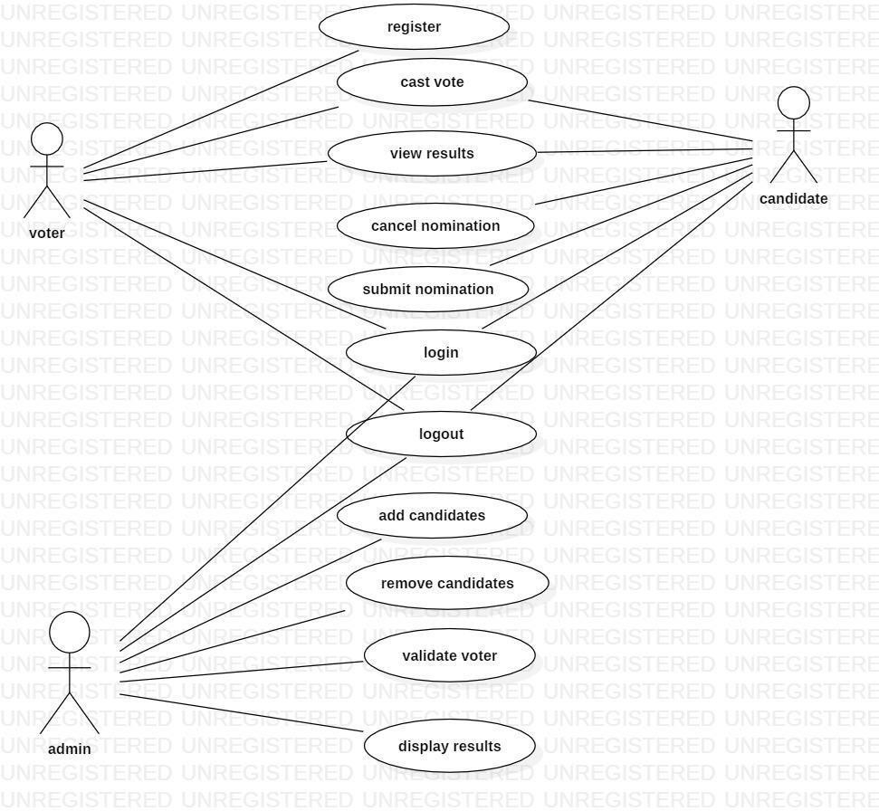

This usecase diagram shows that a voter can login and logout of the system ,cast the vote, update profiles, manage votes, manage candidates, manage voters, display results.

Class Diagram:
It represents the structure of the system showing systems classes, attributes, operations and relation- ships among among the objects.It is a basic notation for other structure diagrams in UML

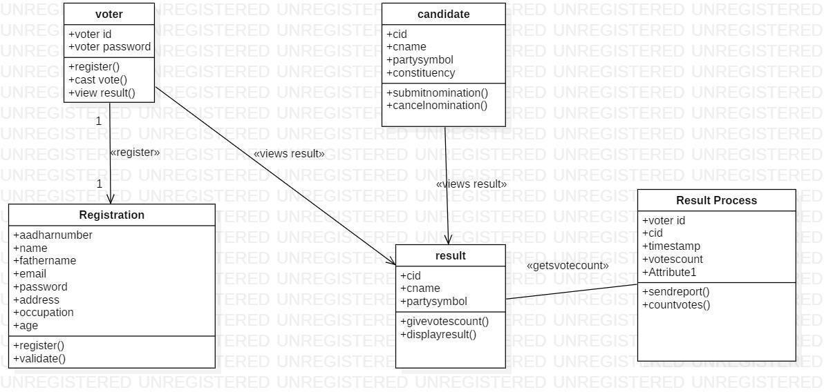

This class diagram has the following classes:
1)voter 2)candidate 3)result
4) result process 5)Admin

CHAPTER 5
CODING

CHAPTER 6
SCREENSHOT

CHAPTER 7
ADVANTAGE
- Increased Accessibility and Convenience: Voters can cast their ballots from any
location with internet access, using a computer, tablet, or smartphone. This is
particularly beneficial for people with disabilities, citizens living abroad or in remote areas, and those who are sick or busy, as it eliminates the need to travel to a physical polling station and wait in lines.
- Higher Voter Turnout and Engagement: The convenience and flexibility of remote voting reduce barriers to participation, which can lead to a substantial increase in voter turnout, especially among younger, more tech-savvy demographics.
- Cost and Time Efficiency: Online voting significantly reduces the expenses associated with traditional elections, such as printing and transporting paper ballots, renting polling locations, and hiring large numbers of manual counting staff. The automatic counting process also saves considerable time, allowing for the rapid reporting of election results, often instantly after polls close.
- Enhanced Accuracy and Reduced Errors: By automating the vote counting process, online systems minimize the risk of human errors such as miscounts or lost ballots. The systems can also provide immediate feedback to voters, detecting potential problems
like over-voting (selecting too many candidates).
- Improved Security and Auditability (with proper implementation): Reputable
online voting platforms employ robust security measures, including advanced
encryption, multi-factor authentication, and unique voter identification, to protect voter data and ensure the integrity of the vote. Many systems offer detailed audit trails,
allowing administrators to verify that the process was fair and results were not manipulated.
- Environmental Benefits: Eliminating the extensive use of paper ballots and reducing transportation needs for both voters and election materials contributes to environmental sustainability.

CHAPTER 8

Conclusion:

We are designing an alternative voting system besides the conventional voting system . Since , todays world has become very familiar with internet and people don’t find time to go out for voting
By doing this project we were able to bring a new system for online national voting for our country. With the advent of technology and Internet in our day to day life, we were able to offer advanced voting system to voters both in the country and outside through our online voting system.
We are designing an alternative voting system besides the conventional voting system . Since , todays world has become very familiar with internet and people don’t find time to go out for votingGatherings are also very dangerous in this pandemic situations. Providing better solution to overcome the issues with existing system
  - On-line web-based voting system which reduces the cost of voting
  - Instant results of election
  - Higher voter turn-out
  - Enables large number of people to cast their vote evn at remote places
  - Time saving process
  - Improves the accessibility
  - Security and Confidentiality

Future Scope:

- It will increase the overall voting percentage
- It will reduce election expenditure
- It can be made more secure by using the advance security methods like biometrics

FUTURE ENHANCEMENT :
- Fingerprinting
- Cornea Detection

REFERENCES

- https://www.upgrad.com/blog/future-scope-in-education/
- https://www.slideshare.net/onlinestathamlee/the-scope-of- online-education-in-future
- http://purecodingweb.blogspot.com
- www.codewithharry.com
- https://www.w3schools.com/css/

